Project Design Phase -I Solution Architecture

| Date | 11 October 2022 |
| --- | --- |
| Team ID | PNT2022TMID22484 |
| Project Name | Industry-specific intelligent fire management system |
| Maximum Marks | 4 Marks |

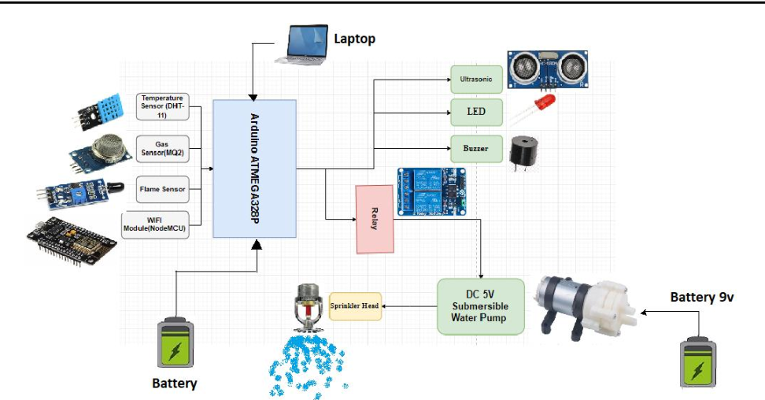

✞ To keep track the temperature of the industries temperature sensor has been used as well as to keep track of the smoke and fire Gas and Flame sensor has been used in this project

✞ Arduino UNO is used as a processing unit that processes the data obtained from sensors and uses the data accordingly for the safety.

✞ Node-red is used as a programming tool to wire the hardware, and software.

The MQTT protocol is followed for communication.

✞ All the collected data are provided to the user through a system application that was developed using the cloud app inventor. The user could make a decision through an

app, whether to water the crop or not depending upon the sensor values. By using the app, they can remotely operate the motor switch.